Electronic Instrumentation and Optoelectronics LAB

LAB2: Getting started with LabView and signal acquisition.

The aim of this LAB session is to remember how to work with LabView, to know the characteristics of your acquisition board and start to do signal acquisition.
The PreLab section is devoted to the analysis of the USB-6008 DAQ acquisition board characteristics.

PRE-LAB Exercises.

PRELAB2-1.- define the following concepts:
- A/D converter Resolution
A/D resolution indicates the converter's ability to distinguish small variations in the level of the input analog signal and map it to a corresponding digital value. Resolution is expressed in bits and determines the number of distinct digital values that the converter can generate to represent the input analog signal.
- Sampling frequency
The sampling frequency as the rate at which an analog signal is measured or sampled to be converted into a digital signal. The sampling frequency is measured in Hz and is typically denoted as fS. The sampling frequency is controlled by the time-base selected by the user. The sampling frequency (or the number of points drawn on screen) place a limit on the time resolution so always be taken indecision +- 1 sample.
- Input dynamic range
The input dynamic range is the range of input signal levels that can be accurately processed by a system or device without distortion or clipping. The input dynamic range is typically expressed in decibels (dB) and represents the ratio between the maximum and minimum input signal levels that can be processed without significant distortion.
- Input impedance
The input impedance is the resistance offered by a device or circuit to an incoming electrical signal. The input impedance is a critical parameter in the design of electronic systems and devices, as it affects the amount of current that can flow into the device and the amount of power that can be transferred to the load. It changes with the frequency.

PRELAB2-2.-Research the National Instruments USB-6008 DAQ specifications and answer the following questions:
- What is the maximum sampling rate of the device? 10kSamples/s
- What is the maximum differential input voltage range? ±10V (±20 V means that |AI+ – (AI–)| ≤ 20 V. However, AI+ and AI– must both be within ±10 V of GND.)
- How many bits is the ADC? It has a resolution of 12 bits.
- How many digital levels does that number of bits give? A 12-bit ADC can generate 2¹² = 4,096 distinct digital levels to represent the analog input voltage.
- If the DAQ is configured so that the input voltage range is 0-5 V, what is the input analog resolution? The maximum digital level that can be generated by the 12-bit ADC is 2^12 = 4,096. The input voltage range of 0-5 V is mapped to the entire range of digital levels, from 0 to 4,095. Therefore, each digital level corresponds to a voltage range of 5 V / 4,096 = 1.22 mV.
PRELAB2-3.-Consult the specifications of and explain the function of components of its input analog circuits.
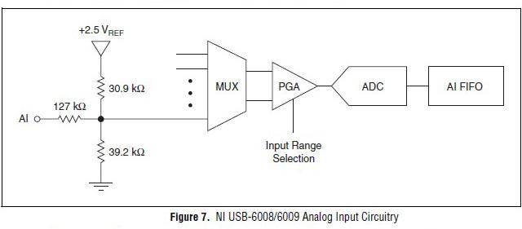
The NI USB-6008/6009 has eight analog input channels that you can use for four differential analog input measurements or eight single-ended analog input measurements. The main blocks featured in the NI USB-6008/6009 analog input circuitry are as follows:
- MUX—The NI USB-6008/6009 has one analog-to-digital converter (ADC). The multiplexer (MUX) routes one AI channel at a time to the PGA.
- PGA—The programmable-gain amplifier provides input gains of 1, 2, 4, 5, 8, 10, 16, or 20 when configured for differential measurements and gain of 1 when configured for single-ended measurements. The PGA gain is automatically calculated based on the voltage range selected in the measurement application.
- ADC—The analog-to-digital converter (ADC) digitizes the AI signal by converting the analog voltage into digital code.
- AI FIFO—The NI USB-6008/6009 can perform both single and multiple analog-to-digital conversions of a fixed or infinite number of samples. A first-in-first-out (FIFO) buffer holds data during AI acquisitions to ensure that no data is lost.

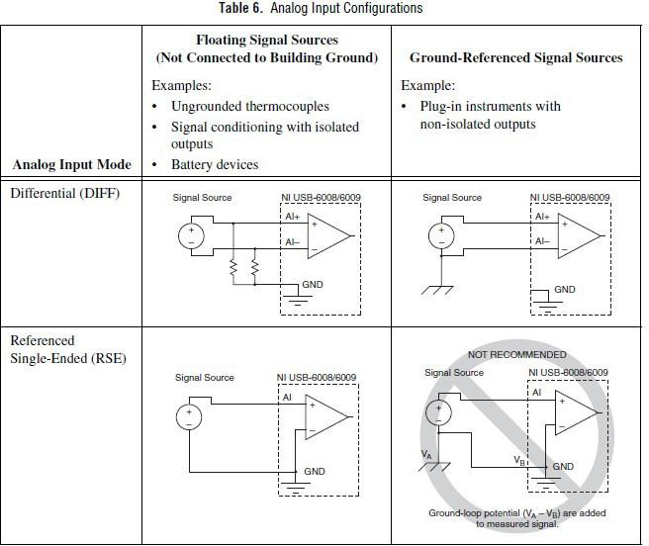
PRELAB3-3.-Consult the specifications of and explain the different configurations for analog inputs in the acquisition board.
You can configure the AI channels on the NI USB-6008/6009 to take differential or referenced single-ended (RSE) measurements.
- Differential Connections with Floating Signal Sources Use DIFF input connections for any channel that meets any of the following conditions:
  - Your application requires input ranges other than ±10 V.
  - The input signal is low level and requires greater accuracy.
  - The leads connecting the signal to the device are greater than 3 m (10 ft).
  - The input signal requires a separate ground-reference point or return signal.
  - The signal leads travel through noisy environments.
  - Two analog channels, AI+ and AI-, are available for the signal.
DIFF signal connections reduce noise pickup and increase common-mode noise rejection and they also allow input signals to float within the working voltage of the device.
- Referenced Single-Ended (RSE) Connections with Floating Signal Sources Only use RSE input connections if the input signal meets all of the following conditions:
  - The input signal can share a common reference point, GND, with other signals that use RSE.
  - Your application permits the use of the ±10 V input range.
  - The leads connecting the signal to the device are less than 3 m (10 ft).
DIFF input connections are recommended for greater signal integrity for any input signal that does not meet the preceding conditions. In the single-ended modes, more electrostatic and magnetic noise couples into the signal connections than in DIFF configurations. The coupling is the result of differences in the signal path. Magnetic coupling is proportional to the area between the two signal conductors. Electrical coupling is a function of how much the electric field differs between the two conductors. With this type of connection, the PGA rejects both the common-mode noise in the signal and the ground potential difference between the signal source and the device ground.

- Differential Connections with Ground-Reference Signal Sources Use DIFF input connections for any channel that meets any of the following conditions:
  - Your application requires input ranges other than ±10 V.
  - The input signal is low level and requires greater accuracy.
  - The leads connecting the signal to the device are greater than 3 m (10 ft).
  - The input signal requires a separate ground-reference point or return signal.
  - The signal leads travel through noisy environments.
  - Two analog channels, AI+ and AI-, are available for the signal.
DIFF signal connections reduce noise pickup and increase common-mode noise rejection. DIFF signal connections also allow input signals to float within the working voltage of the device.
- Use Referenced Single-Ended (RSE) Connections with Ground-Referenced Signal Sources: do not use RSE connections with ground-referenced signal sources. Use differential connections instead.

LAB exercises

To use LabVIEW in the laboratories PCs, we need to log in using a local account. The account is the following: user: c5b#\c5b and password: c5b, whereas # is the workbench. Ex on workbench 10: usr c5b10\c5b, pass: c5b.

LAB2-1.- Complete the first chapter of the “Getting Started with LabVIEW” tutorial that is available as a pdf document in ATENEA.
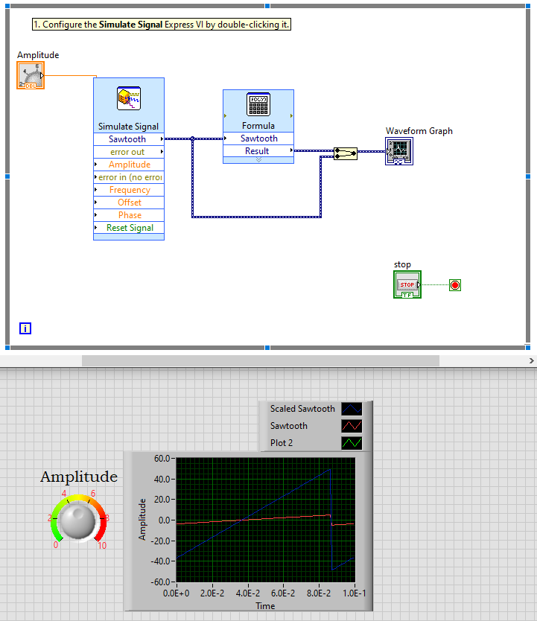

LAB2-2.- Work through chapter four of the tutorial. Each lab workbench has a USB-6008 DAQ device for acquiring data. Connect the function generator and select a sinusoidal waveform of 1 Vpp of amplitude and a frequency of 170 Hz. Make the adequate connections between function generator and the acquisition board. (Connect the input signal in channel AI0.).

When prompted on page 4-2, choose channel AI3. Stop on page 4-6 of the tutorial, just before “Communicating with an Instrument.”
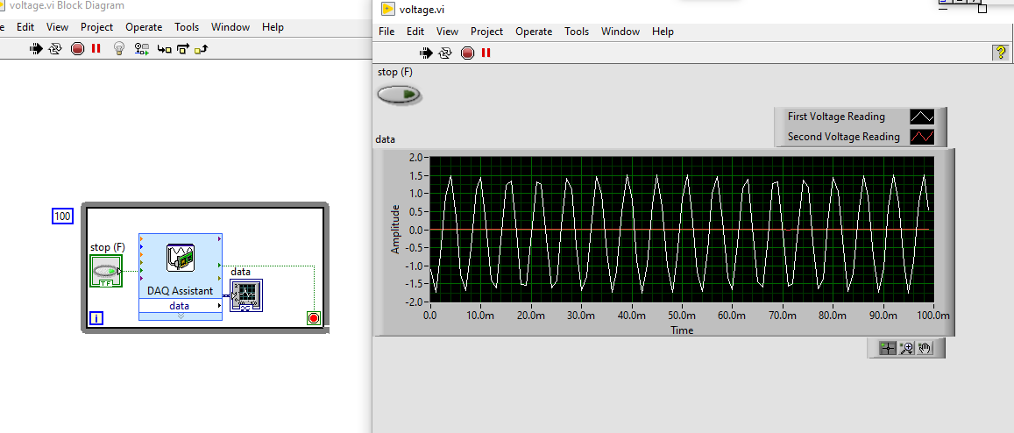

LAB2-3.- Logging Data.

- Open the “Read Voltage.vi” file that you created in the previous section.
- Add a front-panel control to change the Sample Rate of the USB-6008.
- On the block diagram add the “Write to Measurement File.vi.” Be sure the file format is LVM.
- Change the settings so that the user is prompted to enter a filename each time the VI is run.
- Another option for saving data is to right-click in the Waveform Graph on the front panel and select “Export.” You can then paste the data into Excel, Matlab, or a text file. Try it.

- Logging a few seconds of each of the following signals. Save the data and create plots in Matlab or Excel to include in your lab report.

  - A 100 Hz sinusoid with the smallest amplitude possible

  - A 1 kHz square wave from 0 to 5V

  - A 1 MHz triangular signal (1 Vpp) 200KHz, no deixa ficar res més gran “frequency upper limit = 200 000 Hz”

  - A 1V 1 Hz cardiac signal

In each case, explain in your LAB report which are the selected settings in the acquisition board.

